Store Management System

System



Tarun Tudu | Dhruv Garg | Jagnoor Singh

Table of Contents

What is your system idea (in a nutshell)? 3

What information will the system offer the user? 3

In order to achieve this, what data will be stored by the system? 3

Where will you get this data? 4

List of Use Cases your system will implement 4

Who are the target users/actors? 6

What comparable systems are currently available and how does your proposal differ from comparable systems? 6

DIAGRAM: Problem Domain sketch 9

Contributions 10

# What is your system idea (in a nutshell)?

The Store Management System seeks is to streamline and centralize core operations. By merging essential functions such as inventory monitoring, sales processing, and customer management into one platform, this system will reduce human errors and improve efficiency. The system will enable both management and employees to access critical information making it simpler to manage stock levels, process transactions, and keep customer data organized.

This system addresses the common challenges that are faced with store operations, such as making sure stocks are at optimal levels, manual workload is reduced, and customer records are organized. The store management system will improve day-to-day operations and support better decision-making for the store’s overall management by automating repetitive tasks and leveraging data insights.

# What information will the system offer the user?

The system will provide users with:

**Real-time inventory updates:** Information on stock levels, product categories, and restocking alerts.

**Sales data:** Transaction details, daily and monthly sales reports, and best-selling products.

**Customer data:** Profiles, order history, and potential loyalty points.

**Supplier information:** Details on product deliveries and contact information.

**Order status updates:** Information on current orders, whether pending, fulfilled, or canceled.

# In order to achieve this, what data will be stored by the system?

To achieve the system’s functionality, the following data will be stored:

**Product data:** Names, categories, prices, stock quantities, expiry dates, and supplier information.

**Sales data:** Transaction records, including product details, prices, and timestamps.

**Customer data:** Names, contact details, order history, and payment methods.

**Supplier data:** Supplier names, contact information, products they supply, and delivery records.

**Order and transaction data:** Records of current and past orders, including items, prices, and payment status.

# Where will you get this data?

The data for a Store Management System typically comes from several sources:

1. **Point-of-Sale (POS) System:** For capturing transaction and sales data.

2. **Inventory Database:** Details on products, stock levels, reorder points, etc.

3. **Supplier and Vendor Data:** Information on suppliers, pricing, and order history.

4. **Customer Database:** Details on customer preferences, purchase history, and loyalty programs.

5. **Employee Database:** Staff details and access levels.

6. **User-Generated Data:** Data manually entered by store staff, such as inventory updates, new product details, etc. (Due to testing purposes, we will be using dummy data as we do not have access to actual data)

# List of Use Cases your system will implement

1. **Inventory Management**

* Track product quantities in real-time.
* Set and update reorder points and stock levels.
* Manage product categorization within the store.

2. **Sales Management**

* Process customer transactions and update inventory.
* Generate invoices and receipts.

3. **Supplier Management**

* Track supplier details.
* Automate reorders based on inventory thresholds.
* Manage incoming inventory.

4. **Customer Relationship Management (CRM)**

* Store and access customer profiles and purchase history.

5. **Employee Management**

* Assign permissions based on employee roles.

# Who are the target users/actors?

The primary actors interacting with a Store Management System are:

1. **Store Manager:** Responsible for overseeing all store operations, including inventory, sales, employees, and customer interactions.

2. **Sales Associates:** Staff who manage customer transactions, assist with inventory updates, and interact directly with the POS.

3. **Inventory Managers:** Employees responsible for monitoring and updating inventory, coordinating with suppliers, and restocking items.

4. **Cashiers:** Staff handling the checkout process, managing payments, and issuing receipts.

5. **Customers (indirect):** End-users who interact with the system through POS for purchases, loyalty programs, and receiving promotional notifications.

6. **Admin Users**: Higher-level users who have full access to the system for setup, configuration, and access to all reports and functionalities.

# What comparable systems are currently available and how does your proposal differ from comparable systems?

There are some comparable systems available: -

* **Square POS:** An easily usable point–of–scale system that provides information about inventory management, sales analytics, and staff management. It's particularly suitable for small to medium-sized businesses. (<https://squareup.com/us/en/point-of-sale>)

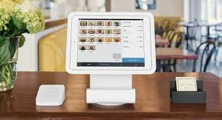

* **Shopify POS:** In Shopify’s e-commerce platform, their system allows retailers to manage both online and offline sales. It includes inventory details, sales reports, and customer management like bills and their names and data. (<https://www.shopify.com/nz/pos>)



* **Lightspeed Retail:** This is another software that is present in the industry. This is the most advanced retail management system; it provides advanced inventory management as it can cover all areas and big data of the store which is precise and well-managed. It is suitable for larger businesses. [(Lightspeed Retail)](https://get.lightspeedhq.com.au/request-quote-h?utm_campaign=OCEA%20-%20AU%2FNZ%20-%20EN%20-%20Search%2FAW%20-%20General%20-%20Brand%20-%20ACQ%20-%20Instapage%2Frequest-quote-h%20-%20TEST%206&utm_source=google&utm_medium=cpc&gad_source=1&gclid=Cj0KCQjwm5e5BhCWARIsANwm06hKe9gUuwrFjgVIu7Oo7Q2BB71yPR6bwFJrMFkRrk9-DlcUb-ltNXAaAi1fEALw_wcB)



* **Vend:** A cloud-based point-of-sale system also focused on inventory management and customer loyalty. (<https://www.myob.com/nz/apps/vend-pos>)

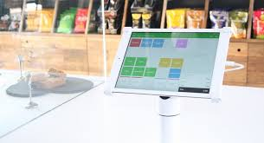

* This platform focuses on the same areas, that is inventory, sales management, and the employee and we are also focusing on the same things.
* ***But how our proposal is different from this:***
* **Customization: -** Our system was developed for an advanced and user-friendly interface. It allows the customer to use it as their business needs, unlike other systems that provide only one one-size-fits-all approach.
* **User Friendly:** We provide the most innovative and easily designed software for the stores. Its streamlined user interface was developed for ease of use and to minimize the training time given to the staff.
* **Product analytics:** The most important feature that we are adding to our software is that it provides enhanced and precise information about the stock which are selling fast, and which items are very slow in selling. So that users can identify the important items for their store.

# DIAGRAM: Problem Domain sketch

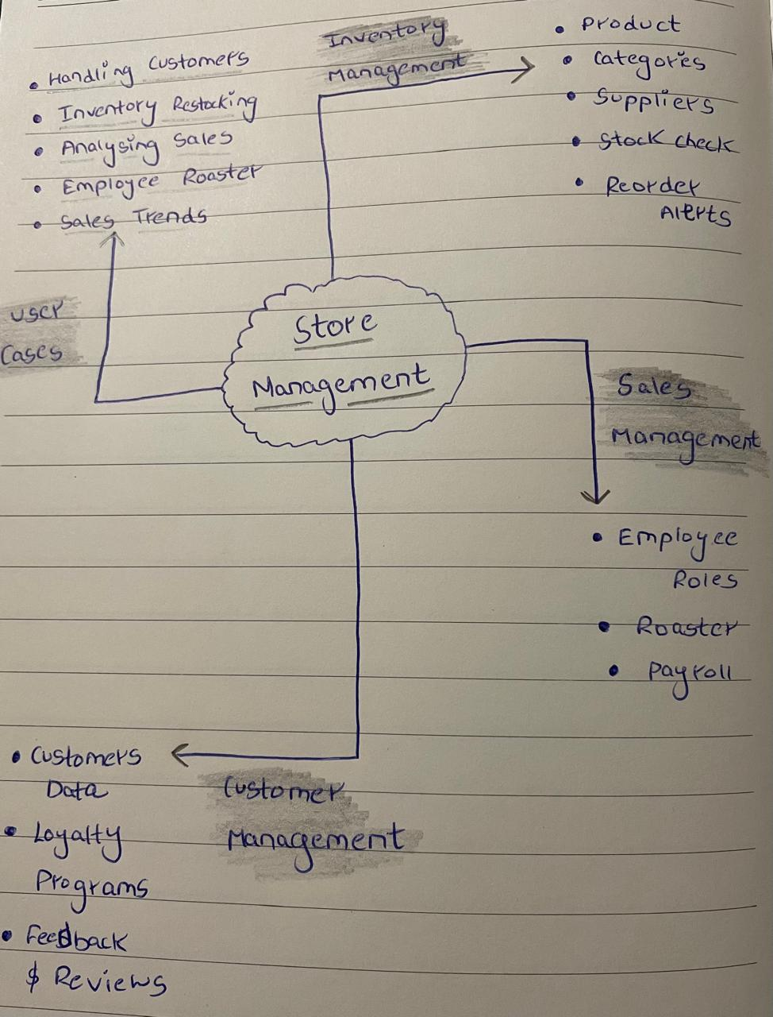

# Contributions

|  |  |
| --- | --- |
| **Group Members** | **Contributions** |
| Tarun | * What is your system idea (in a nutshell)? * What information will the system offer the user? * In order to achieve this, what data will be stored by the system? |
| Jagnoor | * Where will you get this data? * List of Use Cases your system will implement * Who are the target users/actors? |
| Dhruv | * What comparable systems are currently available and how does your proposal differ from comparable systems? * DIAGRAM: Problem Domain sketch |